PROJECT REPOT TEMPLEATE

RETAIL MANAGEMENT APPLICATION USING SALESFORCE

TEAM ID :NM2023TMID18342

1. INTRODUCTION
   1. overview:

this is the process that facilitates easy procurement of desider merchandise from retail stores for the sole purpose of personal consumption. It is an elaborate process that includes multiples steps for attracting the customer to the store and then meeting their needs and requirements.

Purpose:

1.retail management refers to the process of helping customers find products in your store.

2.it includes everthing bfrom increasing your customer pool to hoe products are presented and how you fufil a customer need

3. a good store manager help customers leave the store with a smile.

PROBLEM DEFINITION & DESIGN THINKING

2.1 Emapthy map :

An empathy map is a collaraborative visualization used to ariculate what we know about a particular type of users it externalize knowledge about users in order to

1. create a shared understanding of user needs and
2. aid in decision making

EMPATHY MAP

|  |  |
| --- | --- |
| PROJECT NAME | RETAIL MANAGEMENT APPLICATION USING SALESFORCE |
| TEAM ID | NM2023TMID18342 |
| DATE | 21.3.2023 |

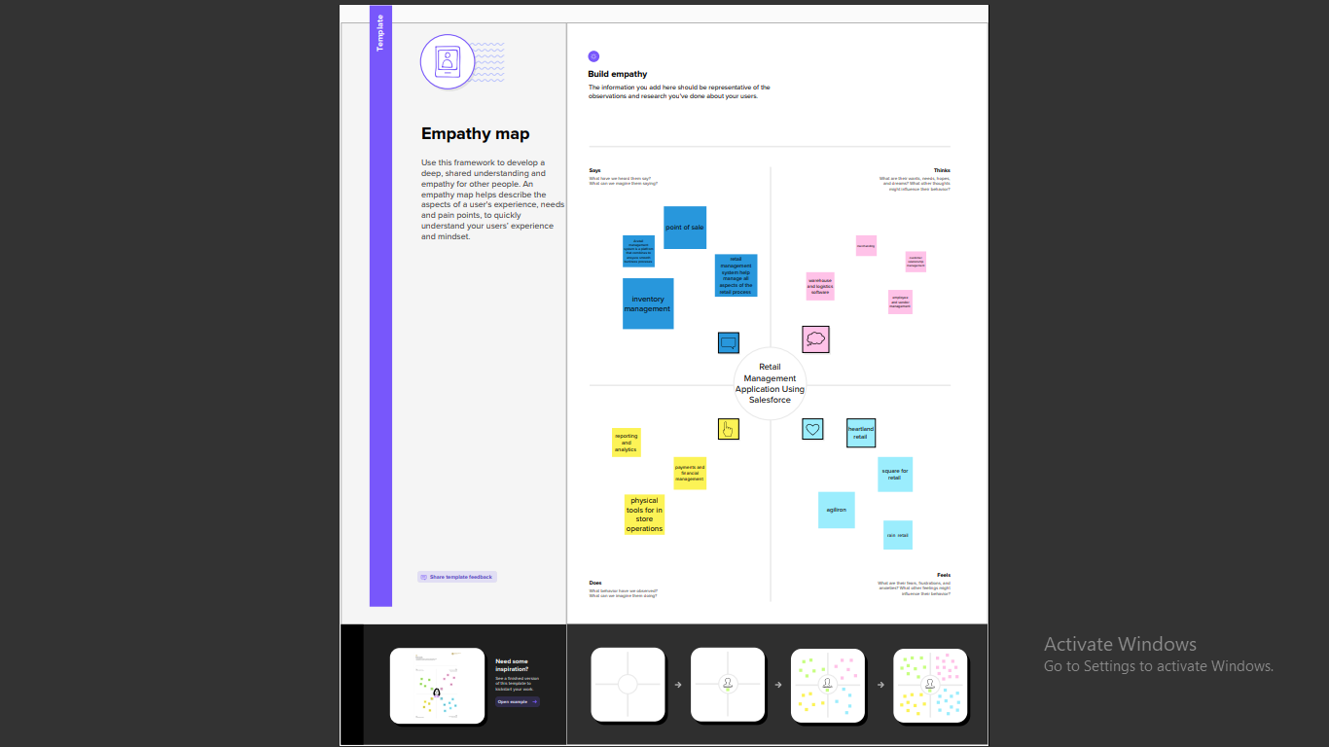

2.2 Brainstorming:

Brainstorming is a group problem-solving methed that involves the spontance contribustion of creative ideas and solutions. This technique requires intensive freewheeling discussion in which every meber of the group is encouraged to think aloud and suggest as many ideas as possible based on their knowledge.

|  |  |
| --- | --- |
| PROJECT NAME | RETAIL MANAGEMENT APPLICATION USING SALESFORCE |
| TEAM ID | NM2023TMID18342 |
| DATE | 21.3.2023 |
| NAME | KANIMOZHI.R |

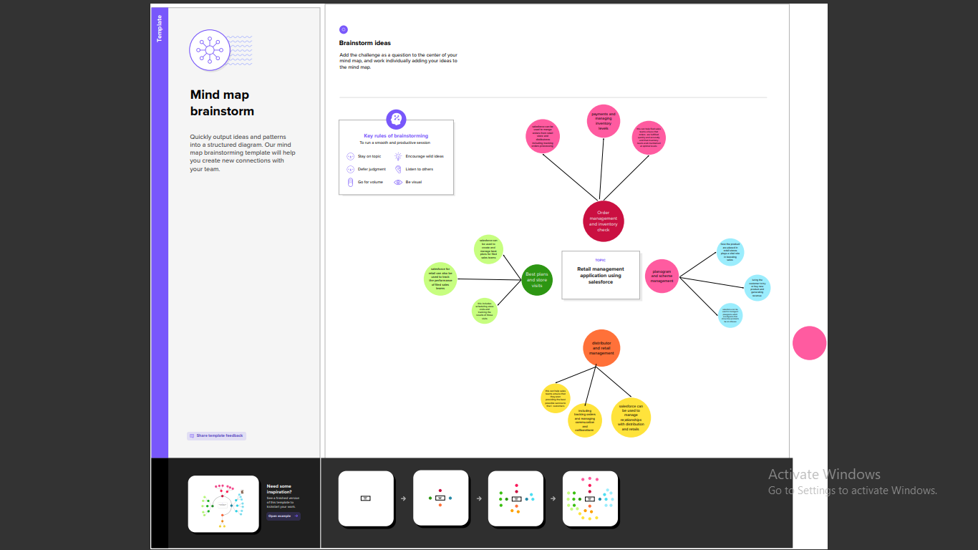

3.RESULT

3.1 DATA MODEL :

|  |  |  |  |
| --- | --- | --- | --- |
| Object name | | Field label | Data type |
| 1 | Display/tracking | Display/tracking | Text |
| Recent | Recent | Text |
| 2 | Accounts | Accounts | Text |
| Products | products | Text |

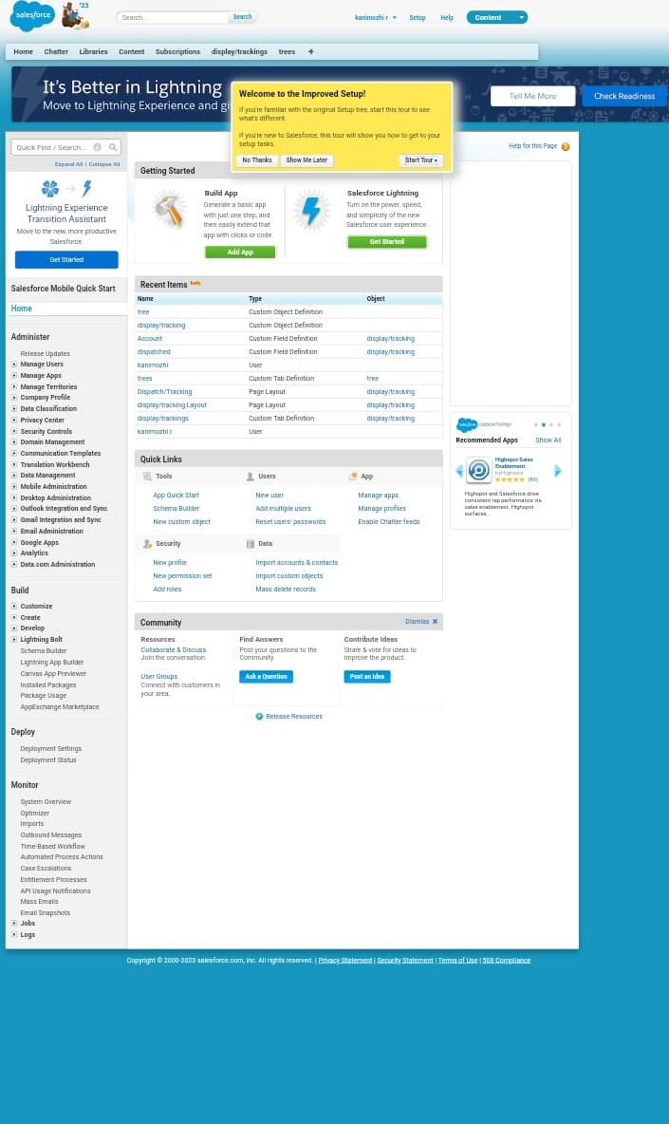

4. TRAILHEAD PROFILE PUBLIC URL

Team Leader -https://trailblazer.me/id/kani34

Team Member 1 -https://trailblazer.me/id/kavin187

Team Member 2 -https://trailblazer.me/id/mmahalakshmi1https://trailblazer.me/id/mmahalakshmi16

Team member 3 -https://trailblazer.me/id/moorthi14

5. ADVANTAGES &DISADVANTAGES

Advantages:

1. requires less capital
2. more profit margin than wholesalers
3. better customer relation credit facility
4. no liability towards the buyers

Disadvantages

1.requriers more marketing costs

2. goods selling skill is required

3.high competition

4. no benefit of bulk buying

6.APPLICATIONS

A retail app is simply a soft ware that lets sellers and buyers transact their business online. Apps for retail business are a gold mine when it comes to improving shopping. Shop owners are now able to obtain important information about clients so as lead them into purchasing.

7. conclusion

Retail thus enjoys many unique features. Inefficiency in retailing leads to lows profitability of the retailers and lower service outputs for the consumers. Steps to strengthen the position of the retailing industry must be taken. Such steps may include establishment of retailers co-operatives ,merger and buy-out ,use of technology to the greatest possible extent, setting up of non-store retailing centers and increase in franchisee network.

8. FUTURE SCOPE

The project a very vast scope in future. The project be implemented on internet in future.